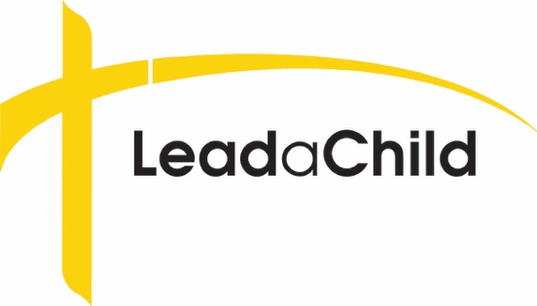
Kids Helping Kids
Enabling children
in 3rd world countries
to attend a Lutheran school

Dear Parents,

Your child’s Lutheran school is collecting a portion of their 2018/19 weekly chapel offering and sending it to LeadaChild, an international educational ministry that exists to share the love of Jesus with children around the world through Christian education.

For over 50 years, LeadaChild has been supporting Lutheran day schools, afterschool programs, and educational outreach ministries. We are currently serving educational ministries in 23 countries around the world. We send funds to support student scholarships, teacher salaries, and school supplies. We are also intensifying our efforts to provide international educators with ongoing professional development and training in effective ways to share God’s Word with children.
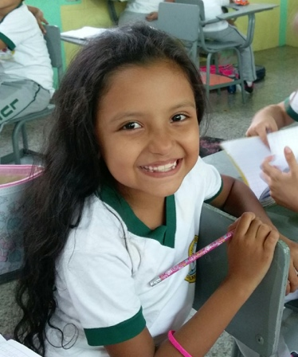
By assisting your child(ren) with plans to share a special offering with LeadaChild, you are teaching them about the importance of spreading the Gospel and getting involved with God’s mission to share the wonderful message of new life found in the Bible.

Our theme this year is “Good News has a Name… Jesus!”
Our goal is that thousands and thousands of children around the world will daily hear the Good News of a God that loves them, a Savior that has rescued them from sin, and a Holy Spirit that fills their hearts with faith, hope, and salvation!
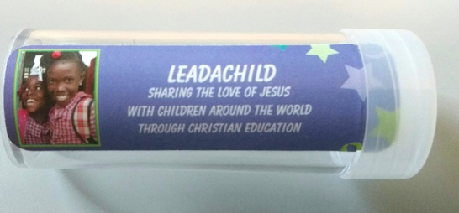
We have sent special coin tubes to your school/Sunday school for the children to collect their offering. Your teachers and school administration will let you know when the offering is being collected. It’s amazing to see what children can do to serve others and make a big impact for the sake of the Gospel!

Check out our website at www.leadachild.org or sign up for our new LeadaChild app (at the app store).

God bless,
Dr. Phil
Dr. Philip Frusti
Executive Director, LeadaChild

13505 S. Mur-len Ste. 105 #331 Olathe, KS. 66062 913.839.3135

